**Project Design Phase-II**

**Technology Stack (Architecture & Stack)**

|  |  |
| --- | --- |
| Date | 15 October 2022 |
| Team ID | PNT2022TMID10231 |
| Project Name | Airline Data Analytics for Aviation Industry |
| Maximum Marks | 4 Marks |

**Technical Architecture:**

The Deliverable shall include the architectural diagram as below and the information as per the table1 & table2.

**Example: Airline Data Analytics For Aviation Industry**

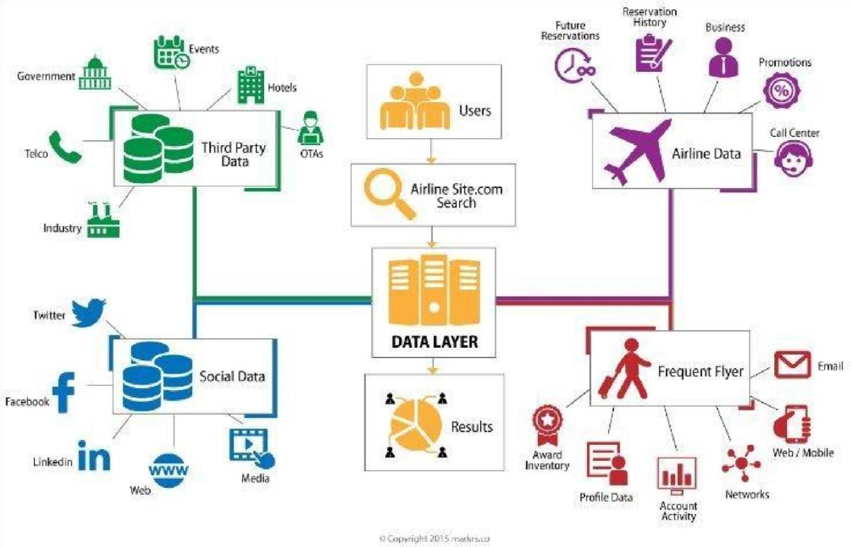

**Table-1: Components & Technologies:**

|  |  |  |  |
| --- | --- | --- | --- |
| **S.No** | **Components** | **Description** | **Technology** |
| 1. | User Interface | How user interacts with application.  Example: Mobile App | HTML, CSS, Java Script,  Excel |
| 2. | Application Logic-1 | Logic for a process in the application | IBM Watson STT service, Python |
| 3. | Application Logic-2 | Logic for a process in the application | IBM Watson Assistant |
| 4. | Database | Data Type, Configurations | MySQL, NSQL |
| 5. | Cloud Database | Database service on cloud | IBM DB2, IBM  Cloudant |
| 6. | File Storage | File Storage requirements | IBM Blocks Storage or other storage service or Local File system |
| 7. | External API-1 | Purpose of External API used in the application | IBM Weather API |
| 8. | External API-1 | Purpose of External API used in the application | Aadhar API |
| 9. | Infrastructure (Server/Cloud) | Application Deployment on Local System/Cloud Local Server  Configuration: Cloud  Server Configuration | Local, Cloud Foundry |

**Table-2: Application Characteristics:**

|  |  |  |  |
| --- | --- | --- | --- |
| **S.No** | **Characteristics** | **Description** | **Technology** |
| 1. | Open-Source  Frameworks | List the open-source frameworks used | Technology of open- source framework |
| 2. | Security  Implementations | List all the security/access controls implemented, use of firewalls. | Example: SHA-256,  Encryption, IAM Controls,  OWASP |
| 3. | Scalable  Architecture | Justify the scalability of architecture | Cognos Used |
| 4. | Availability | Justify the availability of application (e.g: use of load balancers,  distributed servers) | AWS Used |
| 5. | Performance | Design consideration for the performance of the application (number of requests per second, use of Cache, use of CDN’s) | Dashboard,Reports,Stories |